Ranger Training Camp
Requirements:
- Must have completed the 4th grade by June 30, 2021
2. Must be a Discovery Ranger.
3. Must NOT have entered the 7th grade by September 1, 2021
Where: Camp Berry Honey Grove, PA
When: August 4-7, 2021
Check-in: 9:30 AM August 4th
Graduation: 11 AM August 7th
Who: Royal Ranger Boys Grades 4 - 12
Junior Training Camp
Requirements:
- Must not have reached the age of 18 before the end of camp.
- Must have completed 6th grade by
June 30, 2021
- Must have completed one Leadership Merit _________
^{number}
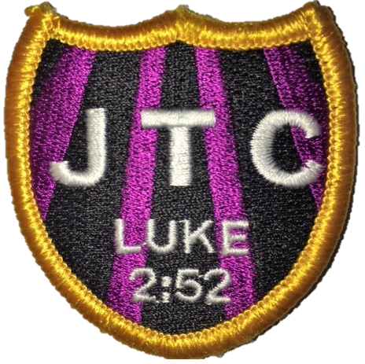
Registration:
$170 if postmarked by June 15, 2021
$194 if postmarked after June 15 and by
June 30, 2020
$218 if postmarked after June 30, 2021
Chartered Outpost Discount:
15% (Multiply the above by 0.85 and round
to nearest dollar) Outpost #? ______
Deposit:
Advanced Junior Training Camp
Requirements:
- Must not have reached the age of 18 before the camp ends
- Must have completed 7th grade by
June 30, 2021
- Must have completed Junior Training Camp __________ _____________
^{Date} ^{Location if not PennDel}
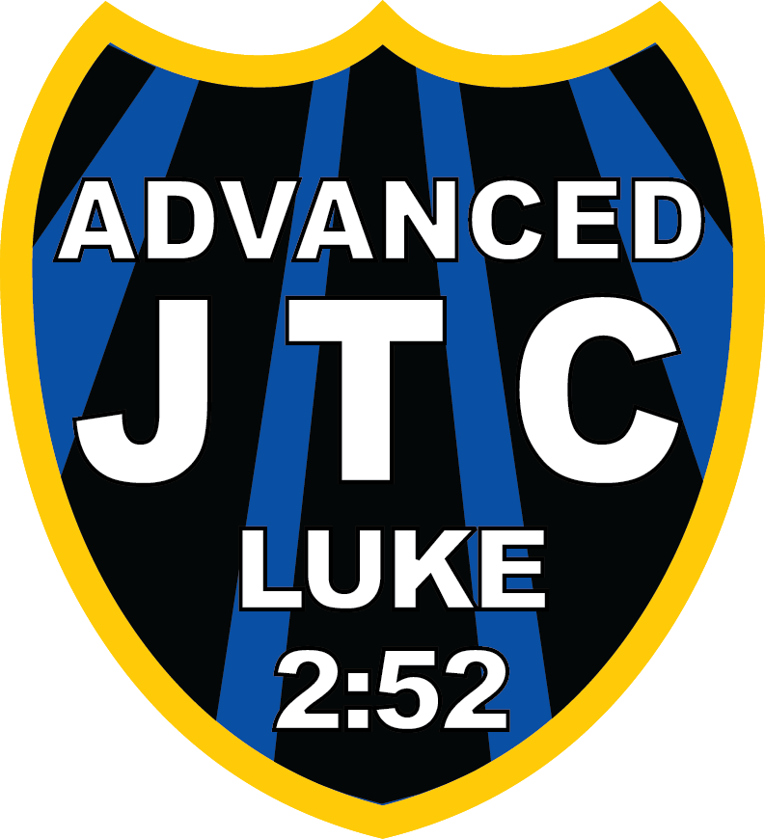
$ 80 Deposit required with Application
Checks Made payable to: PDJLDA Royal Rangers.
Send check with this application, permission slip,
Medical form, and Group Leader’s recommendation
To: Christopher Vincent
361 Byers Rd
Chester Springs, PA 19425

T-shirt Information; Check one
Youth L S M L XL 2XL 3XL

______________________________ __________________________ ______ _______
^{Last Name} ^{First Name} ^{MI} ^{Suffix}
________________ ______ ____________ ________________________________________
^{Date of Birth} ^{Age} ^{Last Grade Completed} ^{Boy's Email Address}
________________________________________________________________
^{Mailing Address}
_____________________________________ ________ ________________
^{City} ^{State} ^{Zip}
(______)-________________________ (______)-_____________ (_________________________)
^{(Area Code)- Home Phone Number} ^{(Area Code)- Cell Phone Number} ^{(Whose)}
_______________________________________ (_________________________)
^{Parent's Email Address} ^{(Whose)}
____________________________________ _____________________________________
^{Mother's or Guardian's Name} ^{Father's or Guardian's Name}
Same Address Yes No Same Address Yes No
Questions: Contact PDJLDA Coordinator Chris Vincent (413) 329-0647 dcvincent1960@gmail.com
Medical Information

____________________________ _______________________ _____ _______ _____________
Last Name First Name MI Suffix Birthdate
REQUIRED INFORMATION:
General Information: The PennDel Network Royal Rangers office has the prerogative to accept or reject any person based upon the Royal Ranger’s health history.
Please check Yes or No in responding to the below information:
Yes No Yes No Yes No
Sinus Condition |  |  | Shortness of breath |  |  | High Blood Pressure
Ear Problem |  |  | Skin Infection |  |  | Allergy – Asthma
Lung Problem |  |  | Hearing Difficulty |  |  | Heart Trouble
Poor Eyesight |  |  | Diabetes |  |  | Appendix removed
Taking prescription medicine |  |  | Wear Contact Lenses |  |  | Fainting or dizzy spells
Any reaction to drugs or medicine of any type |  |  | Any medical care in past year |  |  | Any surgery within past year
Any disorder preventing strenuous activity |  |  | Exposed to infectious disease in past 3 weeks |  |  | Hepatitis in past 6 months
Special diet required |  |  | Food Allergies
Any item above checked Yes please explain below;
Food or Drug Allergies: _______________________________________________________________________
Current Medications and dosages: ______________________________________________________________
__________________________________________________________________________________________
Physical Limitations or Medical Facts We Should Know: _____________________________________________
__________________________________________________________________________________________
Other Remarks: ____________________________________________________________________________
Give latest date of inoculation or vaccination against the following: (month/day/year)
Tetanus ____/____/____ Small Pox ____/____/____ Measles ____/____/_____ COVID -19 ____/____/____
Typhoid ______/____/______ Diphtheria ______/____/______ Polio ______/____/______
Parent or Guardian: In your opinion, Is the applicant physically able to attend the PennDel Network Royal Rangers, JLDA? Yes No
Parent/Legal Guardian Consent: The signature of a parent or legal guardian is required for a minor to attend the 2021 PennDel Network Royal Rangers Junior Leadership Development Academy, August 4-7, 2021. The parent’s or legal guardian’s signature below indicates permission to administer medical attention to the minor in the event of a medical emergency.

_____________________________________________________ ____________________
Signature of Parent or guardian Date of Signature
IN CASE OF EMERGENCY, CONTACT:
Name ______________________________________ Relationship ___________________________________
Daytime Phone (_____)______________________ Evening Phone (______)___________________________
Group Leader's Recommendation for Attendance

____________ ___________________________ __________________________________
Outpost # Section Network/District
______________________________________________________ _____ ______________________________
Church Name Pastor's Name

___________________________________________________ (_____)-_______________________
Church Mailing Address (Area Code)-Church Phone Number

______________________________________________ ________ ____________________
Church City State Zip
______________________________________________ _______________________________
Church Insurance Company Covering Boys and Men Policy #

Evaluation: (within the last 2 years for JTC or since taking JTC for AJTC)
Leadership positions held in the outpost; (Patrol Leader, Quartermaster etc.) ___________________________
__________________________________________________________________________________________
__________________________________________________________________________________________
Merits/classes he has helped to teach: __________________________________________________________
__________________________________________________________________________________________
__________________________________________________________________________________________
Examples of Community and church leadership he has done: ________________________________________ ____________________________________________________________________________________________________________________________________________________________________________________

I recommend _______________________________________ to participate in the Ranger Training Camp/Junior Training Camp/Advanced Junior Training Camp (Circle One) of the Junior Leadership Development Academy.

Recommending Commander’s Signature _______________________________________________________

_______________________________________________ (_____)- ________________________
Commander’s Name (Area Code)- Commander’s Phone Number

__________________________________________________________ __________ ____________________________
Commander's Address State Zip

_____________________________________________________________________
Commander's Email
Permission Slip
2021 JLDA, August 4-7
Camp Berry Honey Grove, PA

I do hereby authorize________________________________________________ to attend Junior Leadership Development Academy at the PennDel Network Royal Rangers Camp Berry, Honey Grove, Pennsylvania, and I also give permission for my child to participate in all planned activities at the same. I understand the arrangements and feel that adequate precautions are planned to ensure the safety of those involved.

While striving to ensure a safe and closely supervised environment, the Junior Leadership Development Academy and its staff, the PennDel Ministry Network Royal Rangers, and the PennDel Ministry Network Council of the Assemblies of God cannot be held responsible for any unforeseeable accident or injury which may occur during the course of the activity.

I understand that I will be notified in the case of a medical emergency. However, in the event that I cannot be reached, I give my permission to hospitalize and/or secure the services of a licensed physician, surgeon, or anesthetist in providing the necessary care for my child as named on this form and the required Medical Record form. I understand that the Junior Leadership Development Academy and its staff, the PennDel Ministry Network Royal Rangers, and the PennDel Ministry Network Council of the Assemblies of God, will not be responsible for medical expenses incurred, but that such expenses will be my responsibility as parent or guardian.
Emergency Contacts:
1^{st Contact}; Name _____________________________________________ Relationship____________________
Home Phone (______)________________________ Work Phone (______)________________________
Cell Phone (______)__________________________
2^{nd Contact}: Name _____________________________________________ Relationship ___________________
Home Phone (______)________________________ Work Phone (______)________________________
Cell Phone (______)__________________________

My Signature certifies that I agree to the above and that the information I provided on this page, the Application, and the Medical Form are accurate and complete to the best of my knowledge and I give my permission for my son or ward to attend the camp.

Signed __________________________________________________ Date _________________________

