Backpacking Action Camp

Penn-Del Junior Leadership Development Academy

**Date:** October 29 – 31, 2021

**Location:** Tuscarora Trail with Camp Base at Camp Berry Honey Grove, PA

**What:** Participants will learn backpacking and will backpack 20-25 miles, part or all of which will be on the Tuscarora Trail

**Cost:** $120 ($ 100 if Chartered Outpost) by October 1st – this camp is limited to the first 20 registrations received

**Who:** Adventure Rangers who are graduates of AJTC, Expedition Rangers (currently in 9th grade or higher –do NOT have to have attended AJTC), and male Royal Ranger leaders

**When: Camp starts at 5:30 PM on Friday and will end at 3:00 PM on Sunday**

.

BD21328_

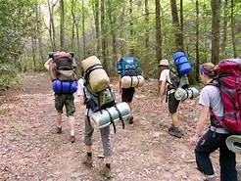

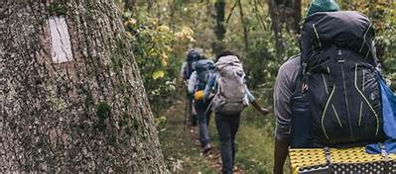

BD21328_

.

BD21328_

* MUST SEND IN APPLICATION AND payment **POSTMARKED NO LATER THAN October 1, 2021**
* Friday night snack, Saturday breakfast, lunch, dinner, and snack, and Sunday breakfast AND LUNCH are all included
* PARTICPANTS UNDER THE AGE OF 18 WILL COMPLETE SOME OR ALL OF THE REQUIREMENTS FOR THE GREEN HIKING MERITS AND ADVANCED BACKPACKING SILVER MERIT)
* **Leaders are encouraged to attend with their boys!** Come and mentor your older boys while you ***both*** learn new skills.

**Mail application to:**

Christopher Vincent

JLDA Director

361 Byers Rd

Chester Springs, PA 19425